**Problem 3a)**

In the figure below, it is shown that on October 24, 2024 the New Horizons spacecraft is 60.18 AU away from the sun, and moving with a velocity of 13.66 km/s with respect to the sun. Assuming this velocity to be constant, it can be calculated that the New Horizons spacecraft traveled 10622016 km or 0.071 AU since October 15, 2024. Therefore, **on October 15, 2024 the New Horizons spacecraft was 60.11 AU from the Sun**.

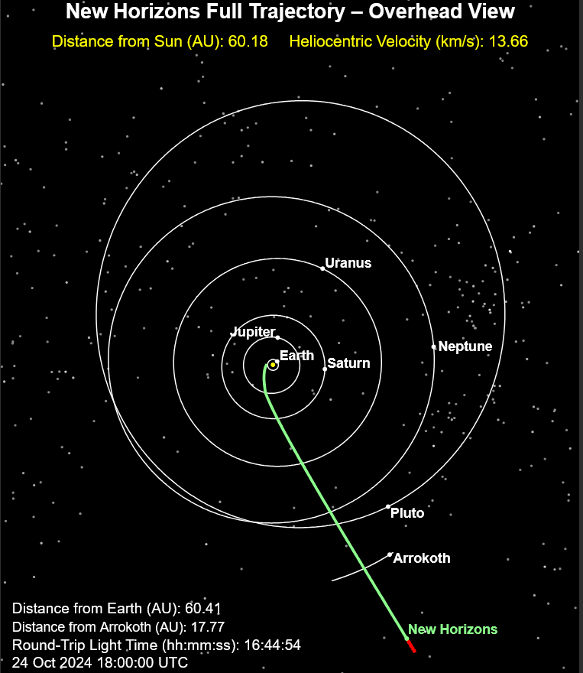

References: JHU APL Current Position – New Horizons Beyond Pluto

<https://pluto.jhuapl.edu/Mission/Where-is-New-Horizons.php>

**Problem 3b)**

|  |  |
| --- | --- |
| **Calendar Date** | **Julian Days** |
| 2006-01-19 12:00 | 2453755 |
| 2007-02-28 12:00 | 2454160 |
| 2011-03-18 12:00 | 2455639 |
| 2015-07-14 12:00 | 2457218 |
| 2019-01-01 12:00 | 2458485 |
| 2021-04-17 12:00 | 2459322 |
| 2024-10-15 12:00 | 2460599 |

Figure 1: New Horizons Timeline in Julian days

Between the New Horizons launch and its closest approach of Jupiter, 405 Julian days (1.1088 Julian Years) passed. The next major event was the crossing of the Uranus’ orbit, which occurred 1479 Julian days (4.0493 Julian years) later. New Horizons closest approach of Pluto occurred 1579 Julian days (4.3231 Julian years) after it crossed Uranus’ orbit. The flyby of Ultima Thule took place 1267 Julian days later (3.4689 Julian years). 837 Julian days (2.2916 Julian years) after the Ultima Thule flyby, New Horizons reach a distance of 50 AU from the sun. Since this accomplishment, 1277 Julian days have passed (3.4962 Julian years) until the latest date of interest 10/15/24. In total, the New Horizons mission has been going on for 6844 Julian days (18.7379 Julian years).